Assignment no.1

Q. Write a C program to add 2 polynomials which are represented using linked list and store the result in the resultant linked list.

CODE:

*#include*<stdio.h>

*#include*<stdlib.h>

*struct* node {

int coef;

int exp;

*struct* node *nxt;

};

*struct* node *p1= NULL;

*struct* node *p2= NULL;

*struct* node *p3= NULL;

void insert_p1(){

*struct* node *new;

new=(*struct* node*)malloc(sizeof(*struct* node));

printf("enter the data of the new node:");

scanf("%d", &(new->coef));

scanf("%d", &(new->exp));

new->nxt=NULL;

*if*(p1==NULL){

p1=new;

*return*;

}

*struct* node *temp;

temp=p1;

*while*(temp->nxt!=NULL){

temp=temp->nxt;

}

temp->nxt=new;

}

void insert_p2(){

*struct* node *new;

new=(*struct* node*)malloc(sizeof(*struct* node));

printf("enter the data of the new node:");

scanf("%d", &(new->coef));

scanf("%d", &(new->exp));

new->nxt=NULL;

*if*(p2==NULL){

p2=new;

*return*;

}

*struct* node *temp;

temp=p2;

*while*(temp->nxt!=NULL){

temp=temp->nxt;

}

temp->nxt=new;

}

void insert_p3(int coef1, int exp1){

*struct* node *new;

new=(*struct* node*)malloc(sizeof(*struct* node));

new->coef=coef1;

new->exp=exp1;

new->nxt=NULL;

*if*(p3==NULL){

p3=new;

*return*;

}

*struct* node *temp;

temp=p3;

*while*(temp->nxt!=NULL){

temp=temp->nxt;

}

temp->nxt=new;

}

void addition(){

*struct* node *temp1=p1;

*struct* node *temp2=p2;

*while*(temp1!=NULL && temp2!=NULL){

int coef1;

int exp1;

*if*(temp1->exp>temp2->exp){

exp1=temp1->exp;

coef1=temp1->coef;

temp1=temp1->nxt;

}

*else* *if*(temp1->exp<temp2->exp){

exp1=temp2->exp;

coef1=temp2->coef;

temp2=temp2->nxt;

}

*else*{

coef1= temp1->coef + temp2->coef;

exp1=temp1->exp;

temp1=temp1->nxt;

temp2=temp2->nxt;

}

insert_p3(coef1,exp1);

}

*while*(temp1!=NULL){

int coef1,exp1;

exp1=temp1->exp;

coef1=temp1->coef;

temp1=temp1->nxt;

insert_p3(coef1,exp1);

}

*while*(temp2!=NULL){

int coef1,exp1;

exp1=temp2->exp;

coef1=temp2->coef;

temp2=temp2->nxt;

insert_p3(coef1,exp1);

}

}

void display(){

*struct* node *temp1=p1;

*while*(temp1!=NULL){

printf("%dk%d + ",temp1->coef,temp1->exp);

temp1=temp1->nxt;

}

printf("\n");

*struct* node *temp2=p2;

*while*(temp2!=NULL){

printf("%dk%d + ",temp2->coef,temp2->exp);

temp2=temp2->nxt;

}

printf("\n\n");

*struct* node *temp3=p3;

*while*(temp3!=NULL){

printf("%dk%d + ",temp3->coef,temp3->exp);

temp3=temp3->nxt;

}

}

int main (){

int n1,n2;

printf("enter the number of terms in both polynomials:\n");

scanf("%d", &n1);

scanf("%d", &n2);

printf("enter thee data of first polynomial:");

*for*(int i=1;i<=n1;i++){

insert_p1();

}

printf("\nenter thee data of first polynomial 2:\n");

*for*(int i=1;i<=n2;i++){

insert_p2();

}

printf("\n\n");

addition();

display();

}

OUTPUT:

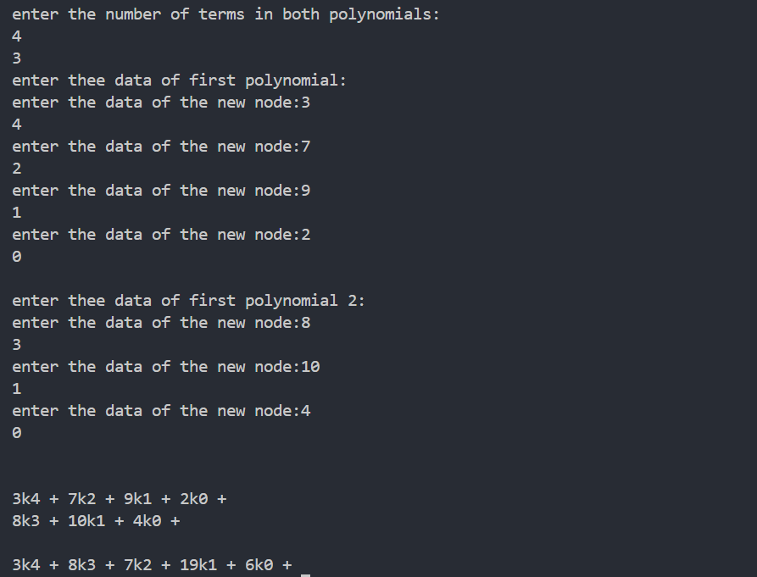

Q)Write a C program to add two polynomials where for the first polynomial is required to be represented using a linked list. For the 2nd polynomial instead of creating a new linked list, add coefficients as soon as you get it as an input from the user. In this entire process you will create only one linked list for two polynomials and for result also

CODE:  
*#include* <stdio.h>

*#include* <stdlib.h>

*struct* node {

int coef;

int exp;

*struct* node *nxt;

};

*struct* node *poly = NULL;

*struct* node* createNode(int coef, int exp) {

*struct* node *newNode = (*struct* node*)malloc(sizeof(*struct* node));

newNode->coef = coef;

newNode->exp = exp;

newNode->nxt = NULL;

*return* newNode;

}

void appendSorted(int coef, int exp) {

*struct* node *newNode = createNode(coef, exp);

*if* (poly == NULL || poly->exp < exp) {

newNode->nxt = poly;

poly = newNode;

*return*;

}

*struct* node *temp = poly;

*while* (temp->nxt != NULL && temp->nxt->exp > exp) {

temp = temp->nxt;

}

*if* (temp->nxt != NULL && temp->nxt->exp == exp) {

temp->nxt->coef += coef;

free(newNode);

*if* (temp->nxt->coef == 0) {

*struct* node *toDelete = temp->nxt;

temp->nxt = temp->nxt->nxt;

free(toDelete);

}

} *else* {

newNode->nxt = temp->nxt;

temp->nxt = newNode;

}

}

void insertPolynomial() {

int n;

printf("Enter the number of terms in the polynomial:\n");

scanf("%d", &n);

printf("Enter the data of the polynomial (coefficient and exponent):\n");

*for* (int i = 0; i < n; i++) {

int coef, exp;

scanf("%d %d", &coef, &exp);

*if* (coef != 0) {

appendSorted(coef, exp);

}

}

}

void display() {

*struct* node *temp = poly;

*if* (temp == NULL) {

printf("The polynomial is empty.\n");

*return*;

}

*while* (temp != NULL) {

printf("%dx^%d ", temp->coef, temp->exp);

*if* (temp->nxt != NULL && temp->nxt->coef >= 0) {

printf("+ ");

}

temp = temp->nxt;

}

printf("\n");

}

int main() {

printf("Enter the data of the first polynomial:\n");

insertPolynomial();

printf("Enter the data of the second polynomial:\n");

insertPolynomial();

printf("The resulting polynomial is:\n");

display();

*struct* node *current;

*while* (poly != NULL) {

current = poly;

poly = poly->nxt;

free(current);

}

*return* 0;

}

OUTPUT:

